Head of Learning Services – Mr Barry Rees

Music Service Manager – Mr Geraint Evans

CEREDIGION
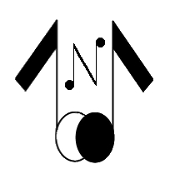
MUSIC SERVICE

FRIENDS OF CEREDIGION
YOUNG MUSICIANS ASSOCIATION

Ceredigion Music Service
Canolfan Rheidol
Rhodfa Padarn
Llanbadarn Fawr
ABERYSTWYTH
SY23 3UE

01970 633 614

FRIENDS OF CEREDIGION YOUNG MUSICIANS ASSOCIATION

Registered Charity Number: 517499

The Friends of Ceredigion Young Musicians Association is a charitable organisation that aims to raise money to support the young musicians of Ceredigion. Monies raised through fundraising activities are entirely dedicated to the purchasing of musical instruments and equipment for the use of the young musicians of the county under the supervision of Ceredigion Music Service.

Friends often hold raffles at concerts performed by Young Musicians, organised by Ceredigion Music Service. Previous prizes include a Violin, a Trumpet, a Clarinet, many bottles of wine, boxes of chocolate, and bath soaps.

These efforts have afforded the association to, over the past two years, purchase: nine Cornets, four Flutes, three Clarinets, three Lap Harps, three Messina Violas, three Tenor Horns, two Clarinet cases, two French Horns, two Oboes, one Bass Clarinet, and one Multi-track Sound Desk for the use of Young Ceredigion Musicians

Members enjoy the benefit of a 5% discount at Cerdd Ystwyth, Aberystwyth.

The Friends of Ceredigion Young Musicians Association has been running for over 30 years, and we hope to see many more years to come where we will come together for the benefit of Ceredigion’s Young Musicians. If you would like to join us in this effort, please see below on how to become a member:

The annual subscription to become a member of the Friends of Ceredigion Young Musicians Association is £10. This can be submitted through completing the Bank Standing Order Form available on the website noted above, or by sending a cheque for £10 payable to:

Friends of Ceredigion Young Musicians Association

Please send the membership form and cheque to the Treasurer:

Mr Gwyn Jones
2 Coed y Bryn
Panteg
ABERAERON
Ceredigion
SA46 0DW
We hope to hear from you soon.

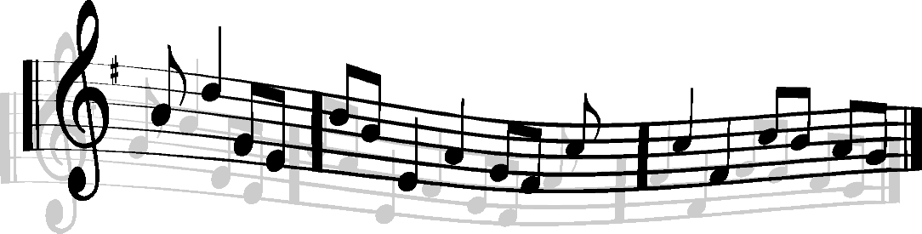

CEREDIGION MUSIC SERVICE

FRIENDS OF CEREDIGION YOUNG MUSICIANS ASSOCIATION

Registered Charity Number: 517499

MEMBERSHIP FORM
If you wish to become a member of the above Association, please complete the following details:
Full Name:
Address:
Post Code:
Phone Number:
Date:
Payment: (tick where applicable)
Annual Subscription: | £10
Tick Chosen Option: | - Complete the Bank Standing Order Form Overleaf
 | - Enclose a Cheque for £10 (see details below)
Please Make Cheque Payable to: | Friends of Ceredigion Young Musicians Association
Please Forward to the Treasurer:  Please enclose a stamped addressed envelope if you  would like a receipt. | Mr Gwyn Jones  2 Coed y Bryn  Panteg  ABERAERON  SA46 0DW

CEREDIGION MUSIC SERVICE

FRIENDS OF CEREDIGION YOUNG MUSICIANS ASSOCIATION

Registered Charity Number: 517499

BANK STANDING ORDER FORM
From:
Full Name:
Address:
Post Code:
To the Manager:
Bank:
Branch:
Address:
Post Code:
Please Pay to: |  | The National Westminster Bank PLC, Aberystwyth
Sorting Code Number: |  | 51-61-06
For the Credit of: |  | Friends of Ceredigion Young Musicians Association
Account Number: |  | 01837478
The Sum of: |  | £10.00 (ten pounds)
Commencing: |  | Forthwith
and Thereafter: |  | Annually
On: |  | The First Day of September (until further notice is given by me)
When Paying, Please Quote: |  | Cerddorion Ifainc Ceredigion Young Musicians
 |  | (And Debit My/Our Account Accordingly)
Name and Number of Account to be Debited:
Name:
Number:
Sort Code:
Signature: |  |  | Date:
Please complete and sign this Form, and the Membership Form overleaf, and forward to the Treasurer: |  | Mr Gwyn Jones  2 Coed y Bryn  Panteg  ABERAERON  SA46 0DW

